**SQL Commands Assessment**

**Q1)** WAQ to display second highest salary in HR schema.

select max(salary) from employees where salary < (select max(salary) from employees);

max

----------

17000.00

(1 row)



**Q2)** WAQ to display name of employee who is earning maximum in his/her department.

select department_id, first_name, salary from employees d where salary = (select max(salary) from employees where department_id = d.department_id);

department_id | first_name | salary

---------------+------------+----------

90 | Steven | 24000.00

60 | Alexander | 9000.00

100 | Nancy | 12000.00

30 | Den | 11000.00

50 | Adam | 8200.00

80 | John | 14000.00

10 | Jennifer | 4400.00

20 | Michael | 13000.00

40 | Susan | 6500.00

70 | Hermann | 10000.00

110 | Shelley | 12000.00

(11 rows)

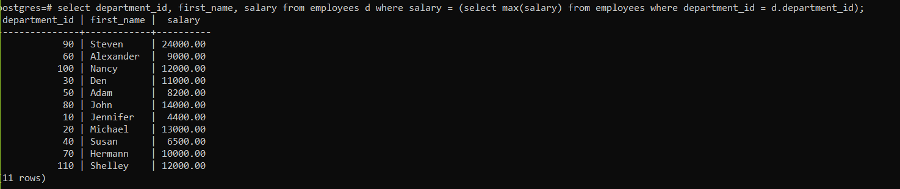

**Q3)** WAQ to display employees count who are working from same location.

select l.city, count(*) from employees e, locations l, departments d where e.department_id = d.department_id and d.location_id = l.location_id group by(l.location_id);

city | count

---------------------+-------

Toronto | 2

South San Francisco | 45

Oxford | 34

London | 1

Munich | 1

Seattle | 18

Southlake | 5

(7 rows)

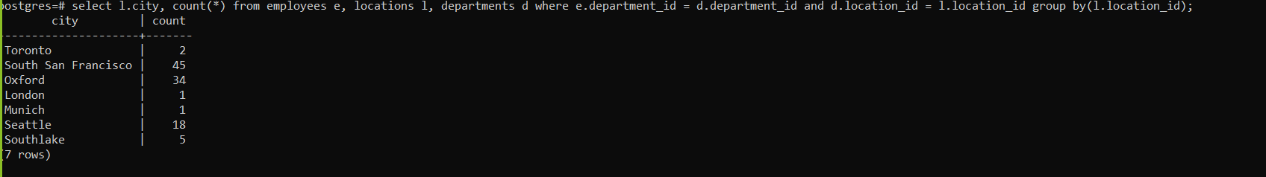

**Q4)** WAQ to display number of employees joined year wise.

select to_char(hire_date,'yyyy') hire_year, count(*) from employees group by(to_char(hire_date,'yyyy'));

hire_year | count

-----------+-------

1996 | 10

1990 | 1

2000 | 11

1994 | 7

1987 | 2

1993 | 1

1997 | 28

1991 | 1

1989 | 1

1998 | 23

1995 | 4

1999 | 18

(12 rows)

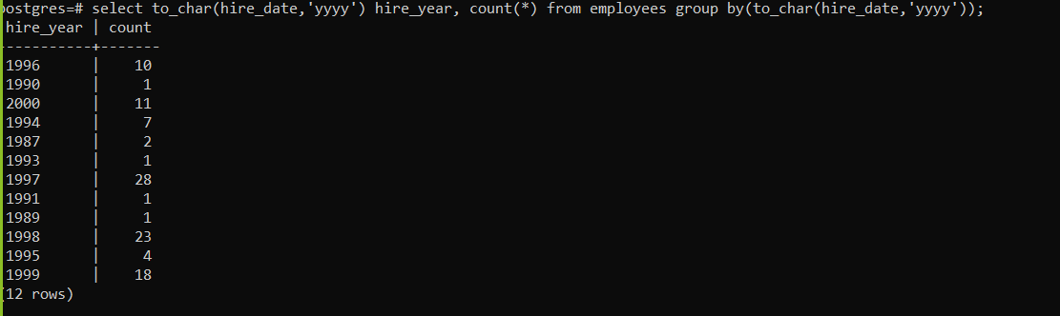

**Q5)** WAQ to top 2 earning employee name and salary in each department.

select first_name, salary, department_id from employees e1 where 2 > ( select count(distinct salary) from employees e2 where e2.salary > e1.salary and

e1.department_id = e2.department_id);

first_name | salary | department_id

------------+----------+---------------

Steven | 24000.00 | 90

Neena | 17000.00 | 90

Lex | 17000.00 | 90

Alexander | 9000.00 | 60

Bruce | 6000.00 | 60

Nancy | 12000.00 | 100

Daniel | 9000.00 | 100

Den | 11000.00 | 30

Alexander | 3100.00 | 30

Matthew | 8000.00 | 50

Adam | 8200.00 | 50

John | 14000.00 | 80

Karen | 13500.00 | 80

Kimberely | 7000.00 |

Jennifer | 4400.00 | 10

Michael | 13000.00 | 20

Pat | 6000.00 | 20

Susan | 6500.00 | 40

Hermann | 10000.00 | 70

Shelley | 12000.00 | 110

William | 8300.00 | 110

(21 rows)

